**INPUT**

<html>

<head>

<title>Choose Flavours For Customizing IceCreams</title>

</head>

<body>

<form method="get">

Enter First Flaovur:<br><input type="text" name="flav1" id="fla2"><br>

Enter Second Flaovur:<br><input type="text" name="flav2" id="fla3"><br>

Enter Third Flaovur:<br><input type="text" name="flav3" id="fla4"><br>

Enter Fourth Flaovur:<br><input type="text" name="flav4" id="fla4"><br>

<input type="Submit" name="submit">

</form>

</body> </html>

<?php

if(isset($_GET['submit']))

{

$p1=$_GET['flav1'];

$p2=$_GET['flav2'];

$p3=$_GET['flav3'];

$p4=$_GET['flav4'];

$flavour=array();

array_push($flavour,$p1,$p2,$p3,$p4);

function sortflav($arr)

{

sort($arr);

echo "<h4> The Flavour Are:</h4>";

echo implode("<br>",$arr);

}

sortflav($flavour);

}

?>

**OUTPUT**

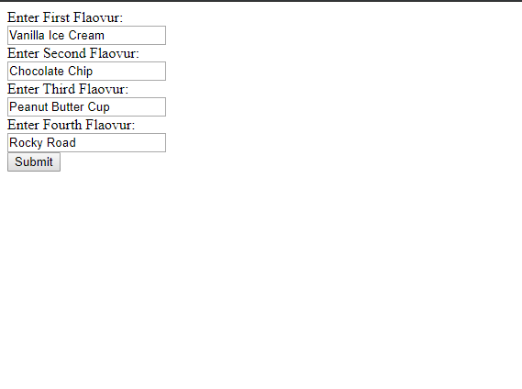



**INPUT**

<html>

<head><title>String Manipulation Without Inbuilt function </title></head>

<body>

<form method="post">

Enter The First String :<input type="text" name="f_name"><br>

Enter the Second String :<input type="text" name="s_name"><br>

Select the Choice:

<select name="choice">

<option value="le">Length</option>

<option value="concat">Concatenation</option>

<option value="comp">Comparison</option>

<option value="plndm">Palindrome</option>

</select><br><input type="submit" name="submit" value="Submit">

</form>

<?php

function length_cal($str_one)

{

$s = $str_one;

$i=0;

while(@$s[$i] !='')

{

$i++;

}

print $i;

}

function concate($str_one,$str_tow)

{

echo "$str_one"."$str_tow";

}

function compare($str_one,$str_tow)

{

if($str_one==$str_tow)

{

echo "Both strings are same";

}

else

{

echo "Both strings are not same";

}

}

function palindrome($str_one)

{

$s = $str_one;

$i=0;

while (@$s[$i] !='')

{

$i++;

}

$strlength=$i;

$reversed_string='';

for ($i=$strlength; $i>-1 ; $i--)

{

$reversed_string.=@$s[$i];

}

if($s==$reversed_string)

{

echo "String is Palindrome";

}

else

{

echo "String is not a Palindrome";

}

}

if(isset($_POST["submit"]))

{

$str_one=$_POST["f_name"];

$str_tow=$_POST["s_name"];

$selection=$_POST["choice"];

switch ($selection)

{

case 'le':

length_cal($str_one);

break;

case 'concat':

concate($str_one,$str_tow);

break;

case 'comp':

compare($str_one,$str_tow);

break;

case 'plndm':

palindrome($str_one);

break;

default:

echo "select valid choice";

break;

}

}

?>

</body>

</html>

**OUTPUT**



